Thumb Speed Test
A Micro:bit reaction game — how fast is your thumb?
By: Adrien B
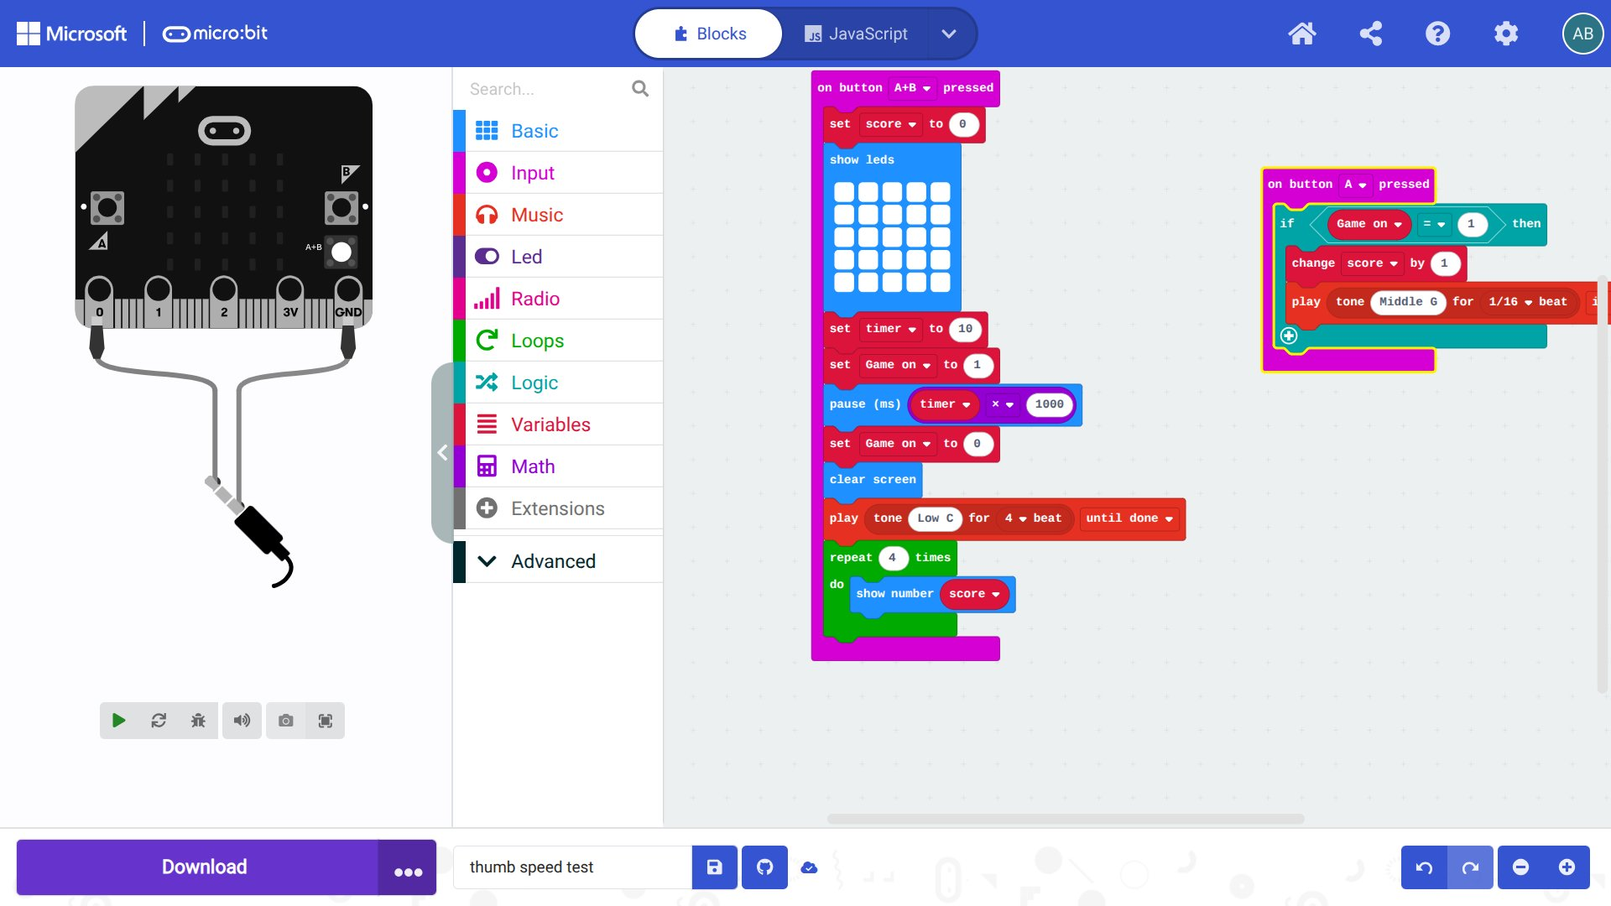
The Thumb Speed Test project open in the MakeCode blocks editor at makecode.microbit.org

Difficulty | Beginner / Intermediate
Language | TypeScript — MakeCode Editor
Hardware | BBC Micro:bit (any version)
Game Length | 10 seconds per round

What Is It?
The Thumb Speed Test is a simple but fun reaction game for the BBC Micro:bit. The goal is to tap Button A as many times as possible in 10 seconds. At the end, your score scrolls across the LED display — challenge your friends to beat it!

How to Play

1 | Press A + B together to start  Hold both buttons at the same time. The LED display fills up with all 25 lights — this means the game has begun!

2 | Tap Button A as fast as you can  For the next 10 seconds, press Button A over and over. Every single tap adds 1 to your score. You'll hear a tiny beep for each tap!

3 | Wait for the end sound  When 10 seconds are up, the LEDs clear and a low booming tone plays. That means time is up — stop pressing!

4 | Read your score  Your score scrolls across the LED display four times so you can read it easily. That's how many taps you got!

Block 1 — Scoring with Button A
This block runs every single time you press Button A. It checks if the game is currently on, and if so, adds 1 to your score and plays a short beep to confirm the tap.

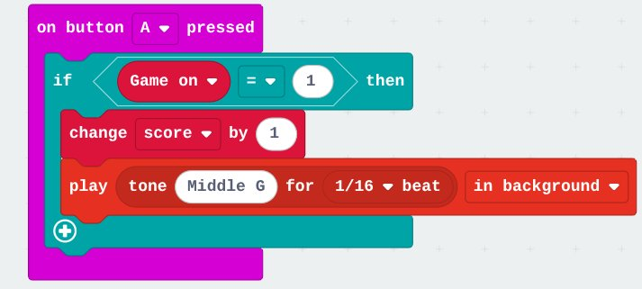
Block 1: on button A pressed — checks game is on, adds 1 to score, plays a beep

What each part does:
- on button A pressed — this hat block listens for Button A. Whenever you press A, everything inside this block runs.
- if Game_on = 1 then — the game uses a variable called Game_on as a switch. It equals 1 while the game is running and 0 when it's not. This stops taps from counting before or after the game.
- change score by 1 — each valid tap adds 1 to the score variable. After 10 seconds of tapping, this is your total!
- play tone 392 Hz, 1/16 beat — plays a quick high-pitched beep (G4 note) in the background so you know your tap was registered without slowing the game down.

Block 2 — Starting the Game (A + B)
This is the main game block. Pressing A and B together triggers it. It resets everything, runs the 10-second game window, then shows your score when time is up.

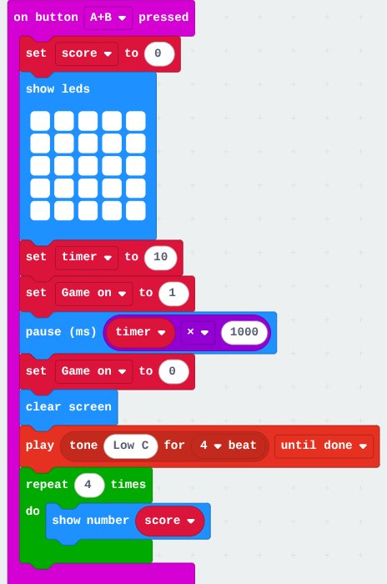
Block 2: on button A+B pressed — starts and ends the game, shows final score

What each part does:
- on button A+B pressed — this hat block only fires when both A and B are pressed at the same time, so you can't accidentally start the game.
- set score to 0 — resets the score to zero so every new game starts fresh.
- show leds (all on) — lights up all 25 LEDs as a visual "game on" signal — it's the start gun!
- set timer to 10 — stores the game length (10 seconds) in a variable called timer.
- set Game_on to 1 — flips the Game_on switch to 1, which tells Block 1 it's okay to count presses now.
- pause (ms) timer × 1000 — freezes here for 10,000 milliseconds (10 seconds). THIS is your scoring window — tap as fast as you can!
- set Game_on to 0 — flips the switch back to 0. Button A taps will no longer count.
- clear screen — turns off all the LEDs to signal that the game is over.
- play tone 131 Hz, Breve beat — plays a deep low C note (like a buzzer) all the way through so you know time is up.
- repeat 4 times → show number score — scrolls your final score across the LEDs four times using a loop, so you have plenty of chances to read it!

Key Coding Ideas Used
- Event blocks (hat blocks) — onButtonPressed() lets the Micro:bit react instantly to button presses without stopping anything else.
- Variables as switches — Game_on is used as a flag: 0 = off, 1 = on. This is a classic pattern in games to control when things are allowed to happen.
- Timing with pause — basic.pause() takes milliseconds, so 10 seconds = 10,000 ms. Multiplying timer × 1000 converts the seconds cleanly.
- Loops — the repeat 4 times loop means we don't have to write show number four separate times.
- Background sound — playing the beep in the background (InBackground mode) means tapping sounds don't interrupt or slow the game.

Ideas to Improve It
- Add a 3… 2… 1… GO! countdown before the game starts.
- Show a smiley face 😊 if you beat your last score.
- Let the player choose the game length (5, 10, or 20 seconds) using A/B before starting.
- Use two Micro:bits connected by radio to compete against a friend.
- Use the LED brightness to show a progress bar filling up as time runs out.

The Completed Code (Blocks)
Here is the full program as it looks in the MakeCode blocks editor — both blocks side by side, exactly as you would see them on screen:


Block 2 — on button A+B pressed (start game)


Block 1 — on button A pressed (score a tap)

Both blocks run independently. Block 2 controls the game timer and score display. Block 1 listens for taps the whole time and only counts them when Block 2 has set Game_on to 1.

Try It Yourself — Run the Code Online
You can open the MakeCode editor in your browser and try this project without needing to download anything. Just click the link below, create a new project, and switch to the Blocks view:

🌐 MakeCode Micro:bit Editor
https://makecode.microbit.org
Click New Project → paste the JavaScript below → switch to Blocks view

The Code in JavaScript
Copy and paste the JavaScript below into MakeCode. Go to makecode.microbit.org, click New Project, then click the JavaScript tab at the top and paste it in. MakeCode will automatically convert it to blocks for you!

📋 How to copy: Click inside the dark code box below → press Ctrl+A (or Cmd+A on Mac) to select all → press Ctrl+C (or Cmd+C) to copy → paste into MakeCode's JavaScript tab.

let Game_on = 0
let score = 0
let timer = 0

input.onButtonPressed(Button.A, function () {
if (Game_on == 1) {
score += 1
music.play(
music.tonePlayable(392, music.beat(BeatFraction.Sixteenth)),
music.PlaybackMode.InBackground
)
}
})

input.onButtonPressed(Button.AB, function () {
score = 0
basic.showLeds(`
# # # # #
# # # # #
# # # # #
# # # # #
# # # # #
`)
timer = 10
Game_on = 1
basic.pause(timer * 1000)
Game_on = 0
basic.clearScreen()
music.play(
music.tonePlayable(131, music.beat(BeatFraction.Breve)),
music.PlaybackMode.UntilDone
)
for (let index = 0; index < 4; index++) {
basic.showNumber(score)
}
})

💡 Tip: After pasting, click the Blocks tab to see your code turned into colourful blocks automatically!

— By: Adrien B —
This document is free to use, share, and adapt for any purpose, including educational and commercial use. No copyright is claimed over this work. The Micro:bit code and all content in this document are released into the public domain under the Creative Commons CC0 1.0 Universal (Public Domain Dedication) — you may copy, modify, distribute, and use this work without asking for permission. No rights reserved.
creativecommons.org/publicdomain/zero/1.0

